Green Refuge

Help create an Urban Oasis and “green” South Acton Estate.

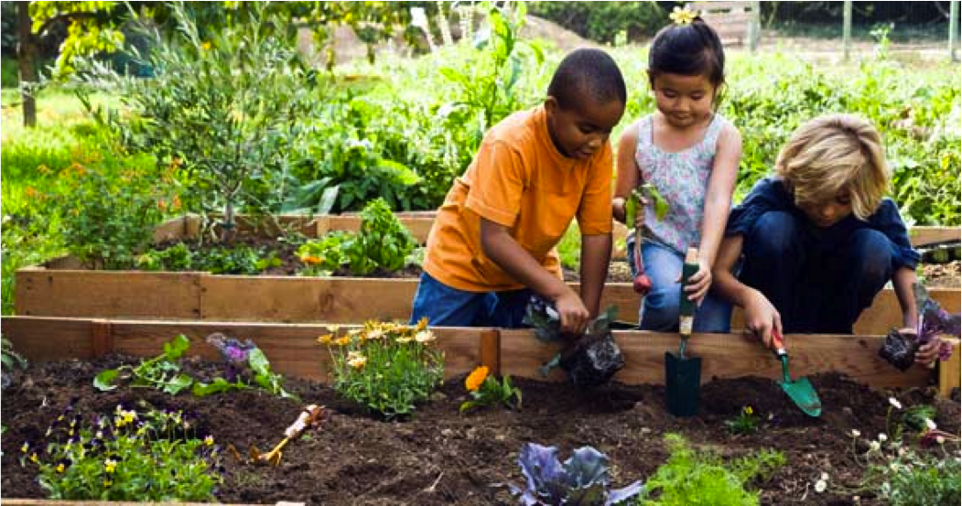

Do you want to help make ecological art, plant vegetables & flowers?

Workshops, community events & harvest festival, engaging people in food growing, arts & community activities.

Making vegetables, herbs & flowers available to residents.

May to October 2018.

Open to all. Do join us! Contact: rachel@artification.org.uk

