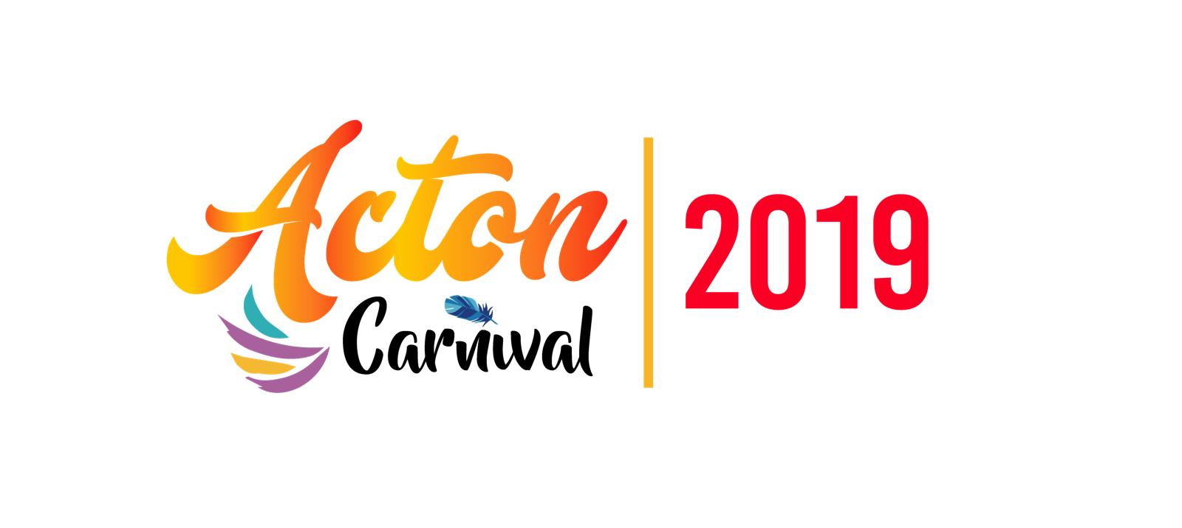
PERFORMERS APPLICATION FORM
We would like to invite you to take part in Acton Carnival 2019 which is taking place on Saturday 13th July 2019, 12pm – 7pm at Acton Park (London W3 7LB)

ARTification are taking the lead on Acton Carnival 2019, with the support of Ealing Council and would like to invite you to take part in this year’s Carnival to do a performance on the main stage.
Acton Carnival is a unique family carnival that provides an opportunity for local community and cultural groups to showcase their organisation. Carnival celebrates identity, history and culture, and is a focus for the local community to enjoy. It’s YOUR Carnival, so be a part of it!
Performers will have a maximum of 20 minutes to perform. (Subject to availability)

If you would like to have a chat about your involvement in the carnival then please contact Chantel Thomas on chantel@artification.org.uk or call 020 8896 9247 (Tuesdays only, or leave a message).
Please complete this form and return it to us on FRIDAY 19TH April 2019

Applications after the deadline may not be considered as publicity will be arranged soon after.
Please return this application form:
By email:
chantel@artification.org.uk

Once we have received your application, you will be contacted shortly via email or phone to let you know whether you have been shortlisted to perform at Acton Carnival.

Performer Name:

Performer Website/ Social Media:

Contact name:

Address:

Telephone no:

Email:

What type of performance will you be doing?

Number of performers on stage?
(Include singer, percussion, dancers etc)

What equipment will you need on stage (i.e. Mics, AV equipment, chairs, tables etc)

Can you provide a sample of videos/files/website links to previous music/ performances?

Do you have Public Liability Insurance?

How long will your performance last? (Max 20 Mins)

This IS a voluntary opportunity, Do you agree to perform for free?
YES / NO
Any other comments:

Don’t forget to complete this form and return it to us on FRIDAY 19th April 2019

