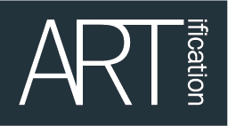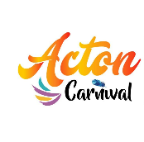

Application Form: Stallholder Hire
Acton Carnival 2022
Saturday 9th July, 12pm – 7pm

Please complete this form and return it to ARTification to the email address at the bottom of the form.

Closing date for applications Friday 27th May 2022

Your Contact details
First Name
Last Name
Trading name

House/Flat Number
Street
Town/City
Postcode |  | Borough
Home Phone No |  | Mobile No
Email
Website
Facebook
Twitter
Instagram

Product category and description
Please list (or add links) and describe the products or services you wish to sell or promote
* Required

Stalls
Pitch area will be allocated on arrival.
You can apply for:
- Single stall space (min 3x3)
- Bring your own Table, Chairs, Gazebo & Equipment.
- No Food or Alcohol sales - Please email if you are a food/drinks trader.

Price Guidelines – (Non-Food Traders)
Charity - £3 per Sq. metre. 3x3 = £27
Community - £5 per Sq. metre. 3x3 = £45
Business - £8 per Sq. metre. 3x3 = £72

The below documents MUST be included with the stall hire application form.
Public Liability Insurance
Risk Assessment
Images of Stall
Images of Product
Price List

Please enter the stall information below
Type of organisation | Charity | Community | Business | £
Standard Single Stall Space 3x3 min  Pitch Size Required | £3 per Sq. metre | £5 per Sq. metre | £8 per Sq. metre

Payment details will be provided once forms have been received and approved.

If you are returning the form as an email attachment, please send it to: traders@artification.org.uk

