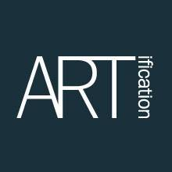
W3 Gallery Artists Submission form
Date:

Exhibition Details
Calling all artists wishing to submit work for the Eco Arts Exhibition taking place between:
Saturday 22th September – Friday 19th October 2018

Eco Arts Exhibition is accepting artwork expressing an environmental, ecological theme.

Deadline for submissions: SUNDAY 9th September 2018

Submissions drop off dates: Saturday 15st September 10am-3pm and Sunday 16th September between 10am – 1pm at the W3 Gallery.

The exhibition will be held at: The W3 Gallery, 185 High St, Acton, London, W3 9DJ

A selection panel will meet to consider submissions
Artists will be informed after the deadline whether they have been accepted.

Contact Information

Fields marked with * are mandatory
Name *

Address

Mobile/Tel Number *

Email *

Artists website/ social media details

General Information
Biographical Details (no more than 100 words)

Would you like to hold a special event/s during the exhibition? If so please describe the event.  (I.e. poetry reading, performance, painting workshops, events etc.) | Yes | No
If yes, please give details:

Would you like to become a volunteer at ARTification? If ‘yes’ we will send you more details shortly. | Yes | No
Do you have any special needs/requirements or health issues that ARTification should be aware of | Yes | No
If yes, please give details:

Details of the work proposed *

Please list the title, medium, dimensions (L x W cm) and price of each work:

Submission 1
Title
Medium
Dimensions
(L x W cm)
Price £

Submission 2
Title
Medium
Dimensions
(L x W cm)
Price £

Submission 3
Title
Medium
Dimensions
(L x W cm)
Price £

Other Information (Additional submissions info)

Image of your artwork/s
(Please attach image/s of your artwork/s on a separate page)
You may send jpeg attachments if replying electronically.

Entry Requirements
- Complete the submission form either by email or post it to the address on this form

- Successful artists selected for this exhibition are required to pay a £10.00 administration fee. More information about this will be sent in an email after you have been selected.

- All artwork must be priced either for sale or not for sale. ARTification will take a 30% commission on any sales.

- If your work is selected for the exhibition it should be labelled clearly with your name, the title of the work and price on the back, together with any handling and/or hanging instructions.

- All selected artists are required to either assist with hanging their artwork or volunteer hours to gallery sit throughout the exhibition.

- Mounted work should be framed and ready to display, with mirror plates attached. Please see Images for reference.
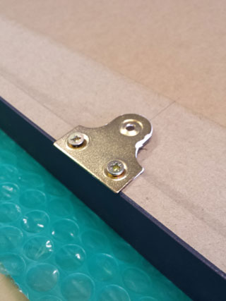

- We reserve the right to refuse artwork that is not suitably presented for display, or is deemed to be offensive by the organisers.

- ARTification has public liability insurance cover, so we recommend that artists insure their work (e.g. check www.a-n.co.uk for insurance cover).

- Work cannot be removed until the end of the exhibition.

- Unless otherwise stated by letter, works exhibited may be photographed for press or charity website purposes in connection with the exhibition.

- Copyright of all works remains the property of the artist/maker.

- All works not sold can be collected at the end of the exhibition by you or a representative with a copy of the delivery receipt. If you are unable to collect your work, please contact us as soon as you can and we can make further arrangements for collection of work.

Our Policy

It is the policy of ARTification to provide equal opportunities without regard to race, religion, national origin, gender, sexual preference, age, or disability.
The information you supply will be used by ARTification for administrative purposes within the terms of the Data Protection Act 1998. We shall not supply it to third parties.

Submitting forms
Please fill in your form online or fill it in by hand and send it to Chantel Thomas on chantel@artification.org.uk

Or post your form to:
Chantel Thomas
ARTification
W3 Gallery
185 High Street, Acton, London, W3 9DJ

