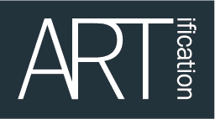

North Acton Pavilion Community Day 2019
APPLICATION FORM

Community Day (Pls Circle which one you are attending) | Spring – Saturday 14th April  Summer – Saturday 14th July  Autumn – Saturday 14th September  Winter – Saturday 14th December
Name:

Website (if you have one):

Contact name:

Address:

Telephone no:

Email:

What type of performance will you be doing?

Number of performers?
(Include singer, percussion, dancers etc)

Do you have Public Liability Insurance
Please indicate how you would like to be introduced by the MC on the day:

How long will your performance last (approx)?

Any other comments:

Don’t forget to complete this form and return it to us on info@artification.org.uk

