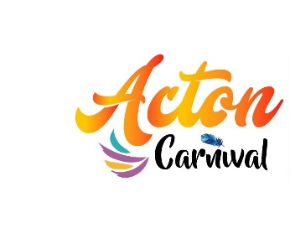
PROCESSION APPLICATION FORM
We would like to invite you to take part in Acton Carnival Procession 2022 which is taking place on Saturday 9th July 2022,10:30am – 12pm in Acton W3
ARTification are taking the lead on Acton Carnival 2022, with the support of Ealing Council and would like to invite you to take part in this year’s Carnival procession.
The route is a short one in terms of time and distance. It’s only a mile and a half from Woodlands Park on Crown Street, down Acton High Street on to East Acton Lane to the festival site in Acton Park. The procession leaves at 10:30am.
Acton Carnival is a unique family carnival that provides an opportunity for local community and cultural groups to showcase their organisation. Carnival celebrates identity, history and culture, and is a focus for the local community to enjoy. It’s YOUR Carnival, so be a part of it!
If you would like to have a chat about your involvement in the carnival, then please contact Symone St Louis on symone@artification.org.uk
Please complete this form and return it to us on FRIDAY 27th MAY 2022

Please return this application form:
By email:
Symone@artification.org.uk

Once we have received your application, you will be contacted shortly via email or phone to let you know more information about your arrangements at Acton Carnival.

Name of organisation:

Contact name:

Address:

Telephone no:

Email:

Please indicate approximate number of people taking part in the procession:
(Include no. Children, youths, adults)

Name’s of Group Leaders:

Others (where ratio of children: adults requires):

Will you be playing music during the procession?

During the procession how will you travel? (i.e. by foot, on a float, other please specify)

Do you have public liability insurance?

Other comments:
Don’t forget to complete this form and return it to us on FRIDAY 27th MAY 2022

